***NARULA INSTITUTE OF TECHNOLOGY***

*(81,Nilgunj Road,Agarpara,Kolkata-700109)*



***C Programming Project***

**Subject code: CS291**

**Stream: CSE1(B)**

|  |  |
| --- | --- |
| **Name** | **Roll no.** |
| **Rudrasish Bagchi** | **430118010065** |
| **Rabindu Chowdhury** | **430118010066** |
| **Subham Mukherjee** | **430118010067** |
| **Vinay Shaw** | **430118010068** |
| **Suvojit Acharyya** | **430118010069** |
| **Samir Imtiaz** | **430118010070** |

Question:-

WAP in ‘C’ to find the following pattern:

A B C D D C B A

A B C C B A

A B B A

A A

**Code:**

**#include<stdio.h>**

**int main()**

**{**

**int i,j,k,l,m=0;**

**for(i=4;i>=1;i--)**

**{**

**for(j=1;j<=i;j++)**

**{**

**printf("%c ",j+64);**

**}**

**for(l=m;l>0;l=l-1)**

**{**

**printf(" ");**

**}**

**for(k=i;k>=1;k--)**

**{**

**printf("%c ",k+64);**

**}**

**m=m+4;**

**printf("\n"); }**

**return 0;**

**}**

Input :-

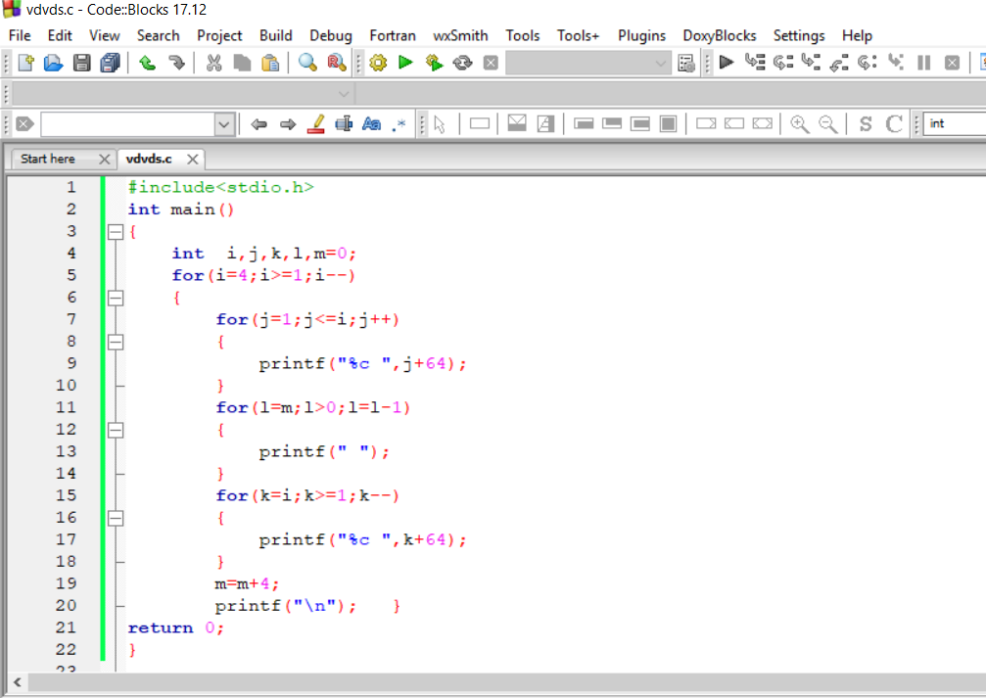

Output:-

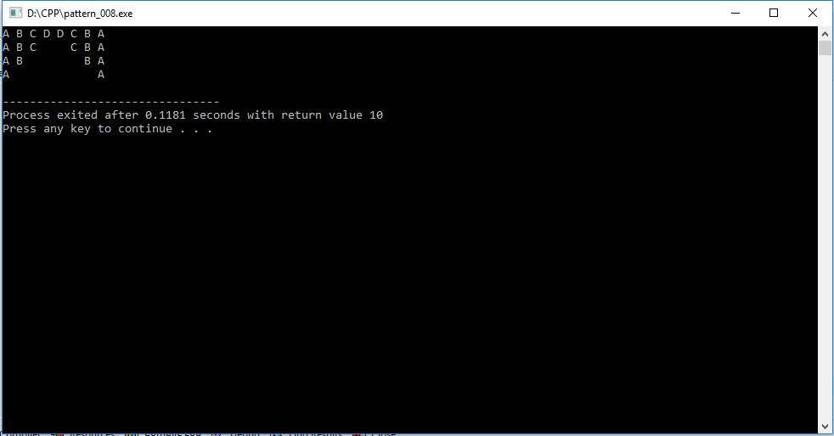

***CONCLUSION***

* We Could not have done this project without the help of our Computer Science faculty Sagarika Chowdhury who had provided us with various information about the topic which is essential regarding the completion of this project.

